**Resultados**

**Radio = 18**

K = 20

Nodos alcanzados = 16816

Bases seleccionadas

[[ 35.1 45.4]

[ 98.7 77.8]

[ 58.8 62. ]

[107.4 111.3]

[ 80.9 68.6]

[ 26.1 0.2]

[ 97.2 46.3]

[ 29.6 91.7]

[ 83.6 40.9]

[ 72.8 -7.1]

[ 33.5 39.7]

[ 22.1 82.2]

[ 39.5 61.9]

[ 54.9 99.4]

[ 63.4 82.1]

[121.7 -23.5]

[ 4.7 -30.5]

[ 21.7 -20.8]

[155.4 -9.2]

[131.7 57.4]]

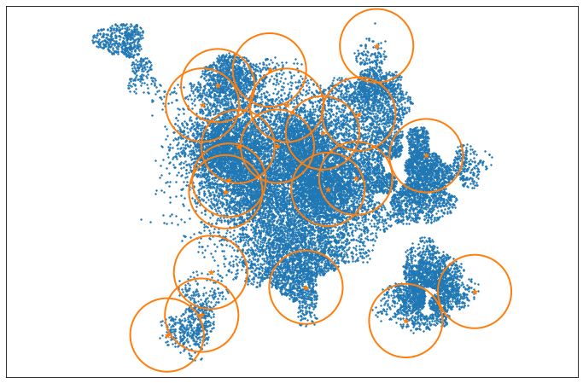

**Radio = 20**

K = 20

Nodos alcanzados = 18101

Bases seleccionadas

[[ 35.1 45.4]

[ 98.7 77.8]

[ 58.8 62. ]

[107.4 111.3]

[ 80.9 68.6]

[ 26.1 0.2]

[ 97.2 46.3]

[ 29.6 91.7]

[ 83.6 40.9]

[ 72.8 -7.1]

[ 33.5 39.7]

[ 22.1 82.2]

[ 39.5 61.9]

[ 54.9 99.4]

[ 63.4 82.1]

[121.7 -23.5]

[ 4.7 -30.5]

[ 21.7 -20.8]

[155.4 -9.2]

[131.7 57.4]]

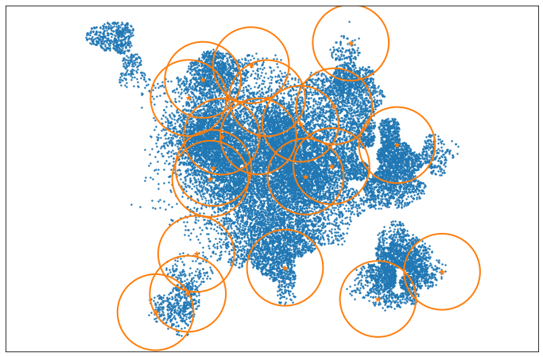

**Radio = 22**

K = 20

Nodos alcanzados = 19077

Bases seleccionadas

[[ 35.1 45.4]

[ 98.7 77.8]

[ 58.8 62. ]

[107.4 111.3]

[ 80.9 68.6]

[ 26.1 0.2]

[ 97.2 46.3]

[ 29.6 91.7]

[ 83.6 40.9]

[ 72.8 -7.1]

[ 33.5 39.7]

[ 22.1 82.2]

[ 39.5 61.9]

[ 27.5 -10.4]

[ 54.9 99.4]

[ 63.4 82.1]

[121.7 -23.5]

[ 4.7 -30.5]

[155.4 -9.2]

[131.7 57.4]]

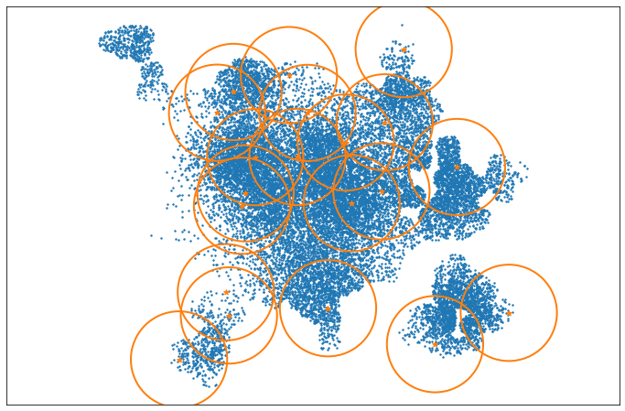

**Radio = 25**

K = 20

Nodos alcanzados = 20299

Bases seleccionadas

[[ 35.1 45.4]

[ 98.7 77.8]

[107.4 111.3]

[ 80.9 68.6]

[ 26.1 0.2]

[ 97.2 46.3]

[ 29.6 91.7]

[ 83.6 40.9]

[ 72.8 -7.1]

[ 33.5 39.7]

[ 22.1 82.2]

[ 39.5 61.9]

[ 38.8 73.9]

[ 58.2 76. ]

[ 54.9 99.4]

[121.7 -23.5]

[ 4.7 -30.5]

[155.4 -9.2]

[109.6 117.7]

[131.7 57.4]]

